STATEWIDE INDEPENDENT LIVING COUNCIL OF TENNESSEE
SILC Quarterly Meeting
Friday November 15, 2024
9am-11pm CST
At
Home2 Suites by Hilton
832 Royal Pkwy, Nashville, TN, 37214
Via Zoom and In-person

Meeting Agenda
Facilitator- Chair

Call to Order
Welcome, Introductions, and Roll Call

- Approval of Previous Meeting Minutes- Chair

- Treasurer/ Finance Reports – Treasurer

- Director Report

- Chair Report

- Old Business

- New Business

- Center Director Reports

  - Empower Tennessee
  - TARP Center for Independent Living
  - Jackson Center for Independent Living
  - Disability Connection Midsouth
  - TRAC Center for Independent Living
  - disABILITY Resource Center

- DSE Membership Report- Cindy Miles

- Public Announcements
  - Please limit comments to 3-5 minutes.

- Adjournment
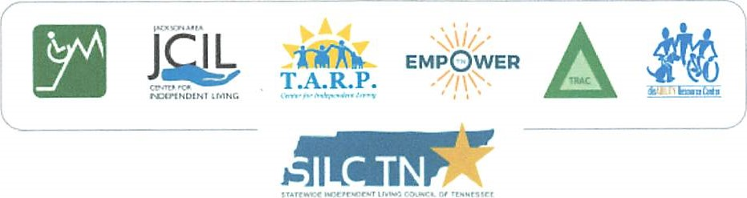
GH1

