STATEWIDE INDEPENDENT LIVING COUNCIL OF TENNESSEE
SILC Quarterly Meeting
Thursday May 26th, 2022
At IOam-1pm CST

At JCIL
23 Federal Drive, Jackson, TN, 38305 Via Zoom and In-person
Meeting Agenda
Facilitator- Vice Chair Denise Wardle
Call to Order
Welcome, Introductions, and Roll Call

Before our regular quarterly meeting we have the fortune of hearing from Jeremy Norden-Paul, Director Division of Program Innovation and Jason Camperlino, Youth Transition Director – MAPS, with the Division of Program Innovation concerning the MAPs program in Tennessee, followed by a brief Q&A time by Council and Public.

- Approval of Previous Meeting Minutes
Motion: Accept Previous Meeting Minutes
Who MotionedWho Seconded
Vote: In Favor Opposed _____Abstained
Resolve: Accepted Not Accepted (Circle One)
- Treasurer/ Finance Reports- Jack Spencer
Motion: Accept Financial Report
Who MotionedWho Seconded
Vote: In FavorOpposed Abstained
Resolve: Accepted Not Accepted (Circle One)

- Director Report
  - SPIL Update
  - ILSG NoA update (5/5/2022 $372,228.00)
  - SILC Congress
    - Possible need of another Ex-Officio
    - State Audit Results Going to ACL
  - Individual Training Plan for Council Members
- Old Business
  - Policy changes to include individual Council training plans (resolve approved)
  - FY 22 SILC Beginning Budget (resolve approved)

- New Business
Executive Committee met on 5/6/2022 over the following:
- 2021-2022 Budget Amendment Approval

Motion: Accept Budget Amendment
Who MotionedWho Seconded
Vote: In FavorOpposed Abstained
Resolve: Accepted Not Accepted (Circle One)
- Executive Director Evaluation
Motion: Accept Executive Committee Recommendation on Eval Results
Who Motioned _________ Who Seconded ________
Vote: In Favor______ Opposed ______ Abstained _____
Resolve: Accepted Not Accepted (Circle One)

- Center Director Reports
disABILITY Resource Center
  - Empower Tennessee
  - TARP Center for Independent Living
  - Jackson Center for Independent Living Memphis Center for Independent Living
  - TRAC Center for Independent Living
- DSE Membership Report- Cindy Miles

- Public Announcements
  - Please limit comments to 3-5 minutes.

- Adjournment
Next meeting is scheduled for
August 18th, 2022 at 10 am CST.
Place TBD
Thank you to everyone!
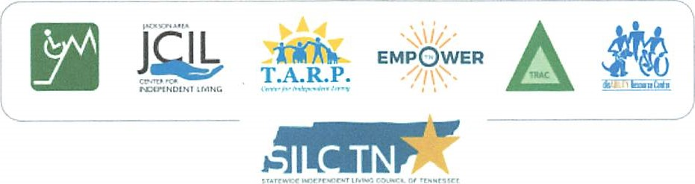
.1

