STATEWIDE INDEPENDENT LIVING COUNCIL OF TENNESSEE
SILC Quarterly Meeting
Friday May 26, 2023
9am-12pm CST
At
The Jackson Center for Independent Living
23 Federal Drive, Jackson, TN 38305
Via Zoom and In-person

Meeting Agenda
Facilitator- Chair Sandi Klink

Call to Order
Welcome, Introductions, and Roll Call

- Approval of Previous Meeting Minutes- Sandi Klink

- Treasurer/ Finance Reports - Jack Spencer

- Disability Innovation Fund: Pathways to Partnerships Grant - Blake Shearer, Ed.S. | Transition Director

- Interim Director Report
  - SPIL Extension 2024 Update
  - SPIL 2025 – 2027 Update
  - Statewide ADA Celebration
  - TN Disability – Preparedness Doc

- Chair Report

- Old Business
  - ADA Celebration Date was adopted.

- New Business
- Introduction of new members

- Center Director Reports
disABILITY Resource Center
  - Empower Tennessee
  - TARP Center for Independent Living
  - Jackson Center for Independent Living
  - Memphis Center for Independent Living
  - TRAC Center for Independent Living
- DSE Membership Report- Cindy Miles

- Public Announcements
  - Please limit comments to 3-5 minutes.

- Adjournment
Next meeting date Friday August 25, 2023, Place TBD
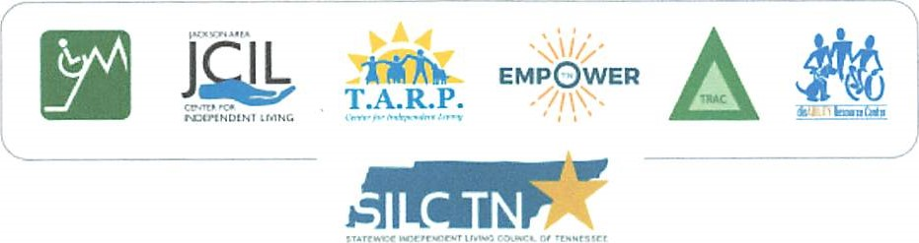
GH1

