STATEWIDE INDEPENDENT LIVING COUNCIL OF TENNESSEE
SILC Quarterly Meeting
Friday November 17, 2023
9am-11pm CST
At
Home2 Suites by Hilton
832 Royal Pkwy, Nashville, TN, 37214
Via Zoom and In-person

Meeting Agenda
Facilitator- Chair Sandi Klink

Call to Order
Welcome, Introductions, and Roll Call

- Approval of Previous Meeting Minutes- Sandi Klink

- Treasurer/ Finance Reports - Jack Spencer

- Interim Director Report
  - SPIL 2025 – 2027 Update
- Chair Report

- Old Business

- New Business

- Center Director Reports

  - Empower Tennessee
  - TARP Center for Independent Living
  - Jackson Center for Independent Living
  - Disability Connection Midsouth
  - TRAC Center for Independent Living
  - disABILITY Resource Center

- DSE Membership Report- Cindy Miles

- Public Announcements
  - Please limit comments to 3-5 minutes.

- Adjournment
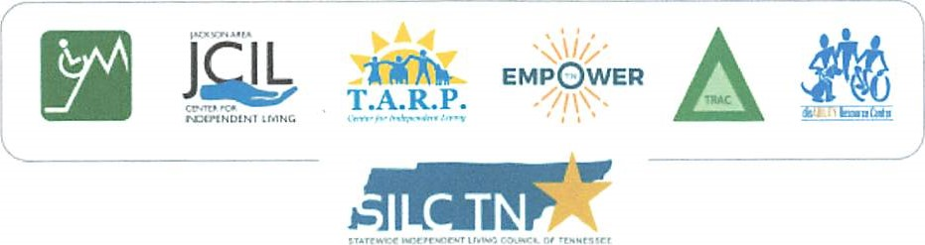
GH1

